

Webaverse

White paper

## Webaverse

A virtual world built on principles.



Adrian Biedzyrcki

CEO

Christopher La Torres

CTO

Jin

Growth

## Abstract



Webaverse is creating an open virtual world where users can build and monetize real-time immersive gaming. Uniquely, all users’ content is created as operable tokens on the Ethereum blockchain.

Creators can drag-and-drop assets (images, 3D models, avatars, scripts) into the game in real-time to showcase and monetize their creations. Users can buy parcels of land on which to persist content. The parcels are embedded in an expanding overworld hub curated by the Webaverse team.

Technologically, we operate an Ethereum sidechain to enable fast, feeless transactions and monetization within the game world. The game feel is inspired by Fortnite and is accessible in the browser. VR is supported.

We introduce the FLUX utility token, LAND non-fungible token, and ASSET non-fungible content tokens that make this possible. We further detail the philosophical, technical, and aspirational aspects of the project.

## Table of Contents



**1 Introduction**

3

1.1 Why

3

1.2 History

3

1.3 Evolving World

1.4 Economy

1.5 Use Cases

4

5

5

**2 Technology**

7

2.1 Engine

7

2.2 Blockchain

9

2.3 Interface

11

**3 Economy**

13

**4 Challenges**

15

**5 Roadmap**

**6 Summary**

16

17

**References**

18

# 1 Introduction



Webaverse builds on years of experiments to present a clear path for creators to monetize virtual world creations while being incentivized to interoperate.

## 1.1 Why



The distinguishing feature of the metaverse will be persistence and interoperability of user-created components.

- Tim Sweeney (Epic Games)

In the metaverse[[1]](https://en.wikipedia.org/wiki/Metaverse):

1. Users will own their items and identities across worlds.
2. Creators will be able to import, operate, and sell their creations on open, decentralized marketplaces.
3. Investors will be able to buy shares in the social capital of virtual worlds and have access to liquidity, backed by an active value economy.

For the first time, with Webaverse, users will be able to create, experience, and monetize operable objects built on standard file formats through a familiar game interface: avatars, inventory, load-outs, and multiplayer hubs. This strong foundation unlocks value by connecting communities in gaming, content creation, and blockchain technology.

We are building Webaverse because we want it to exist.

## 1.2 History



Webaverse builds on years of projects and experiments, bringing virtual worlds together with composable standards.

In 2016 the development of a blockchain-based web virtual reality world Zeo began. On May 21, 2017, there was a git commit that added the following to the README[[2]](https://github.com/exokitxr/zeo/tree/4b7f27b32ed5b09e6b9cdbc854bd3bdbac2622bd):

*“Peer to peer WebVR appstore on a blockchain. Achievement unlocked: Buzzword Bingo”*

In 2018, the Exokit engine development began, which would eventually end up being the state-of-the-art web engine for 3D virtual reality websites used by billion-dollar companies.

On April 18, 2019, the Webaverse team held the first Metaverse Makers Meetup (M3) in Mozilla Hubs.[[3]](https://www.youtube.com/watch?v=auY_jZlOCcY)M3 brought creators from every discipline worldwide to share their creations and find how the projects can interoperate.

Over the years, other projects like Emukit, Exokit Web, Exokit Browser, Exokit Avatars, and XRPackage have built the infrastructure necessary to create Webaverse.

## 1.3 Evolving World



The Webaverse overworld is the entry point where users spawn. The overworld consists of contiguous virtual land on which LAND parcels exist. The overworld can be freely navigated by the user’s avatar and is designed by the team, providing a high-quality entry experience for users.

Webaverse adapts the Seasons from Fortnite Battle Royale concept, which implements "seasons"[[4]](https://en.wikipedia.org/wiki/Fortnite_Battle_Royale#Seasonal_changes) of content that lasts for a limited period. Seasons introduce new themes and elements to the game, such as cosmetics, gameplay mechanics, and changes to the world map.

By analogy, Webaverse development proceeds in seasons, which last ten weeks. With each season, a new area is unlocked in the overworld, containing LAND tokens that can be purchased.

Seasons provide release cadence to the project and provide a formal structure to the timing of promotional in-world events.

## 1.4 Economy



The value flow in our virtual economy is enabled by the FLUX utility token (Ethereum ERC-20). Users use FLUX to transact, create assets (for a fee), and buy space in the Webaverse game world.

FLUX can be used to create and purchase ASSET tokens (ERC-721 Ethereum non-fungible), which represent operable objects in the virtual world. ASSETS include avatars, 3d models, videos, images, and audio.

Transactions happen on the Webaverse Ethereum sidechain, which enables free, nearly instant transactions. FLUX and ASSET tokens can be transferred over to the main Ethereum chain to enable liquidity and trading on open marketplaces like Uniswap and OpenSea, as well as compatibility with other Web3 projects such as DeFi.

## 1.5 Use Cases



### Unlock value for creators

By providing a simple path from creation to decentralized ownership on the Ethereum blockchain, creators are incentivized to create compelling virtual world content and share it.

Users benefit from a closed value loop and the ability to support their favorite creators by purchasing their work.

### Maximum Distribution

Our roadmap includes integrations with other virtual worlds as well, so creators have farther market reach. Open standards like WebXR and WASM enable Webaverse ASSET tokens to be operable in other virtual reality worlds in a permissionless way.

### Discovery

The Webaverse overworld hub provides a discovery mechanism for LAND parcels that are part of the world. The LAND is populated with user-generated ASSETs. This architecture allows for the intuitive and engaging discovery of user-generated content through an evolving development model, as new areas are unlocked in the overworld.

Previous attempts at organizing virtual worlds have faced extreme difficulty from being entropic and static by design, such as being constrained to a fixed grid layout, resulting in a directory of barren worlds.

Themed overworld seasons and events will bring gamers, streamers, and spectators into the world as well.

# 

# 2 Technology



We have developed several unique technologies that make Webaverse possible.

## 2.1 Engine



### Engine

Our game engine is custom-designed to load, render, simulate, and transact ASSET tokens in a networked virtual world.

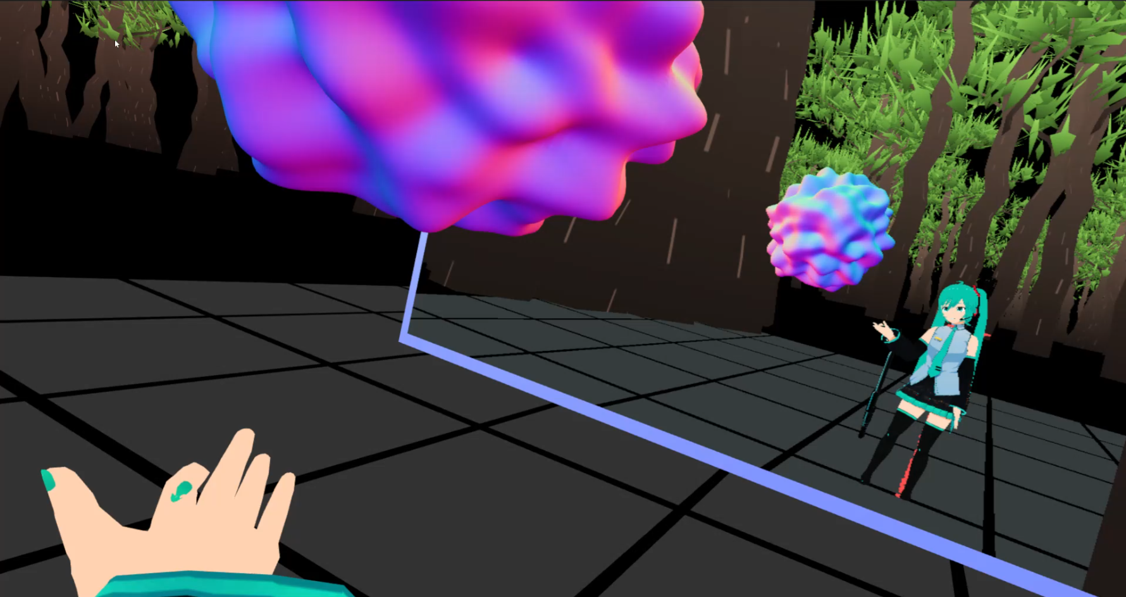

Figure 1: VR avatar exploring art ASSET tokens in the Webaverse engine.

The engine runs in the browser, with support on most computing devices, including desktop, mobile, and VR headsets like Oculus Quest.

Our engine is built using popular components including:

* THREE.js (scene graph)
* PhysX (physics baking and simulation)
* MediaSoup (multiplayer and voice chat)
* yjs (CRDT object sync)
* WebAssembly (native code support)
* WebGL (graphics)
* WebXR (VR)
* WebAudio (audio)

### Avatar System

Our avatar system, based on the popular VRM format, allows for richly animated and customizable avatars. To change avatars, the user can drag-and-drop the .vrm file. There are many sources for VRM files already, such as VRoid Hub and CryptoAvatars.

The avatar system works on both desktop and VR, using custom inverse kinematics technology.

### Standards

Our engine supports the most popular file formats for ASSET tokens content:

|  |  |
| --- | --- |
| 3D Models | GLTF |
| Avatars | VRM |
| Images | PNG, JPG (lossy) |
| Video | MP4, WEBM |
| Audio | MP3, OGG |
| Text | Txt |
| Scripting | JavaScript, WebAssembly |

### Storage

Our backend stores ASSET data in a content-addressable system indexed by the SHA-256 hash of the content. This is used to serve to the clients the data representing virtual worlds and items.

Users can upload content to the storage system using a REST API prior to minting ASSET tokens. This storage is maintained by us for all ASSET tokens. This data is freely replicable.

We are currently using Amazon S3 as our storage backend, but we are looking to use more distributed systems, such as IPFS and Filecoin, in the future.

### Parcel Infrastructure

Every Webaverse LAND parcel is backed by:

1. Parcel storage indexes the ASSET content sources, the virtual world transforms (position, rotation, scale), and per-object state data.
2. MediaSoup presence server, which facilitates WebRTC-based data and media streams between users and runtime content in the parcel.

Our implementation uses MediaSoup, the industry-standard WebRTC SFU (selective forwarding unit), which is also used in popular projects such as Mozilla Hubs.

## 2.2 Blockchain



### Smart Contracts

We have developed Ethereum Smart Contracts to implement the distribution of our FLUX, ASSET, and LAND tokens.

These contracts set the governance rules for issuing our tokens and network minting fees paid for ASSET creation.

Our contracts are available for inspection at <https://github.com/webaverse/contracts>; our contracts were audited by ditCraft, the report of which is available at <https://github.com/webaverse/audit>

### Side Chain

We have developed an Ethereum sidechain based on the popular Go Ethereum client (geth) that allows for fast, feeless transactions.

The sidechain is accessible as a public Ethereum endpoint at <https://ethereum.webaverse.com>. It is compatible with standard Ethereum wallets like MetaMask and tools like Remix. The chain progresses via proof-of-stake mining at a rate of one block per second, but it does not charge user transaction fees.

Users may inspect and replicate the sidechain with regular Ethereum tools.

In the future, we may migrate the side chain to a more distributed solution, such as Flow or Matic. In any such case, all data on the previous chain will be preserved.

### Wallet

The wallet is a dApp (distributed web application) that presents an intuitive trading-card-inspired interface to our FLUX, ASSET, and LAND tokens.

Each token is represented by a trading card representing ownership of the asset. Users can click the cards to visually inspect asset details and on-chain metadata.

### Virtual World

Users create ASSET tokens to represent content in the virtual world; these are accessible from an inventory in the engine and can be placed on parcels of LAND represented by the LAND token.

Turing-complete scripting support (using Javascript and WebAssembly) allows any content and interaction to be emulated in the browser’s existing secure sandbox.

There is a high quality overworld from which LAND parcels are accessed. Parcel owners can design and place ASSETs within their LAND parcels.

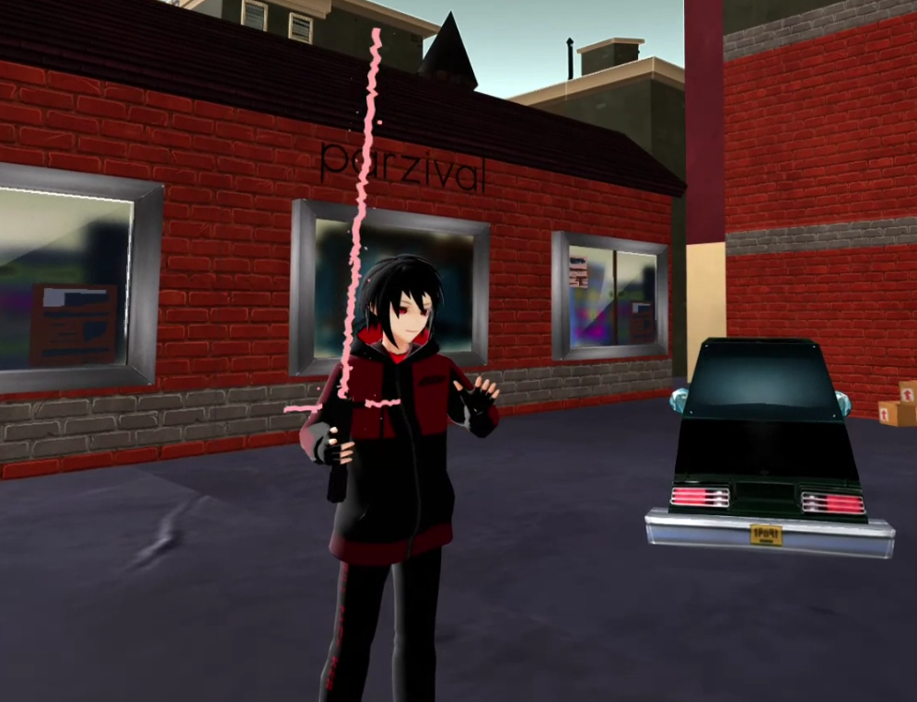

Figure 2: User in VR in Webaverse with on-chain identity (name, avatar)

holding a lightsaber ASSET tokenized item.

Webaverse enables an economy between creators and users inside of virtual worlds. Building on top of the Ethereum blockchain allows for liquidity and decentralized ownership of items.

## 2.3 Interface



### Overworld

Each overworld groups together and provides an overarching theme for a group of LAND parcels. The overworlds are designed by the Webaverse team and rolled out periodically by seasons, where then LAND parcels for the overworld are auctioned to users.

### Parcels

Parcels represent the in-world space that is created by the LAND token owner for that parcel. In-world items (ASSET tokens) can be placed and persistently live in the LAND parcels.

### NFT Discord Bot

We have developed a Discord chatbot that allows users to interact with our Ethereum smart contracts through a command-line interface in Discord. Features include creating ASSET tokens by uploading files, sending FLUX to users, and operating P2P trades and storefronts through intuitive chats with the bot, without needing to install any prerequisite software such as MetaMask.

The Discord bot operates on our side chain. The bot is operationally cheap to maintain and free for users to use. Users pay the standard minting fee (in FLUX tokens) to create ASSET tokens, in accordance with our ASSET smart contracts.

The bot may be installed on other Discord servers related to virtual worlds and crypto/cryptoart and we are looking forward to performing those integrations.

# 

# 3 Economy



The Webaverse economy consists of a fungible currency (FLUX), non-fungible tokens which represent owned content (ASSETs), and non-fungible tokens that represent ownership of space in the virtual world (LAND).

### FLUX

FLUXtokens are the fungible utility token, usable in the virtual world to purchase content and pay platform fees (for minting). By building on the Ethereum blockchain, creators and users will have access to liquidity for the FLUX token.

### ASSET

ASSETtokens represent owned content (game items) and contain verifiable hashes of the asset data that can be downloaded and rendered in the virtual world. The storage of asset data is content-addressed, secured by the SHA-256 hash function.

Examples of ASSET tokens are an avatar, a 3D model, parcel, video, image, or a music file. ASSET tokens can have functionality built directly into them, for example, an item marked as wearable.

Users can inspect any ASSET object’s on-chain metadata (filename, image preview, etc.) using our dApp or standard Ethereum tools.

### LAND

LAND non-fungible tokens represent space in the Webaverse virtual world. Seasons represent themed groups of LAND that are issued periodically.

FLUX, ASSET, and LAND tokens run on top of a Webaverse Ethereum sidechain. The sidechain uses digital signatures and proof of burn (via trusted oracle) to transfer assets between the sidechain and the Ethereum mainnet. This architecture aims to control the fees of running the network and provide for near-instantaneous virtual world transactions.

The NFT Discord Bot allows users to interact with the Webaverse Ethereum sidechain by typing commands in Discord servers. The Discord Bot expects no pre-existing crypto knowledge from the user while enabling users to mint tokens, buy, sell, and trade straight from Discord.

Users can buy, sell, and trade directly in the Webaverse virtual world, in Discord, or a third-party marketplace like OpenSea.

# 

# 4 Challenges



### Content Quality + Density

In a successful virtual world, content quality (effort invested) and density (featureful navigability) must remain high.

We must maintain a high standard of art in the Webaverse overworld. Further, we must maintain a sufficient fee on ASSET token minting to incentivize high quality uploads. We must also ensure that LAND parcels are used to showcase and discover the most meaningful content.

### Tokenomics

Figuring out how to enable the economy between creators and users while reducing spam, speculation, and making sure to reward the people who help build the Webaverse. We want to avoid getting trapped in a local maximum, like lucrative gambling and other forms of abandoning the principles.

### Incentives

Designing the right incentives for our community will be important.

We must look forward to the future and create the incentive structures that will lead to interoperability alignment (in technology and tokens) over the long term.

### Security and Privacy

Enabling more permissionless innovation and greater freedom for creators means there will need to be greater attention paid to security. Webaverse allows for freedom in in-world scripting, which could lead to in-world griefing.

Privacy is also a concern since the Ethereum blockchain allows everybody to see each other's balances and transactions.

# 5 Roadmap



### Token Distribution

When Webaverse launches to the Ethereum Mainnet, initial liquidity for FLUX tokens will be available on Uniswap. We will partner with more exchanges to give users and creators easy access to liquidity.

Discord Bot

The NFT Discord Bot can be invited into any existing Discord community and instantly equip the members with addresses and access to minting, buying, selling, and trading in the Webaverse network.

### Minting Fees

The minting fees are set at a fixed cost of FLUX to incentivize high-quality creations. The contract allows this fee to be changed later.

### Season Schedule

There will be a new Webaverse season rolled out periodically. The initial season will be the Genesis Season, with a design inspired by the Street from Neal Stephenson’s seminal novel Snow Crash, the origin of the term “metaverse”:

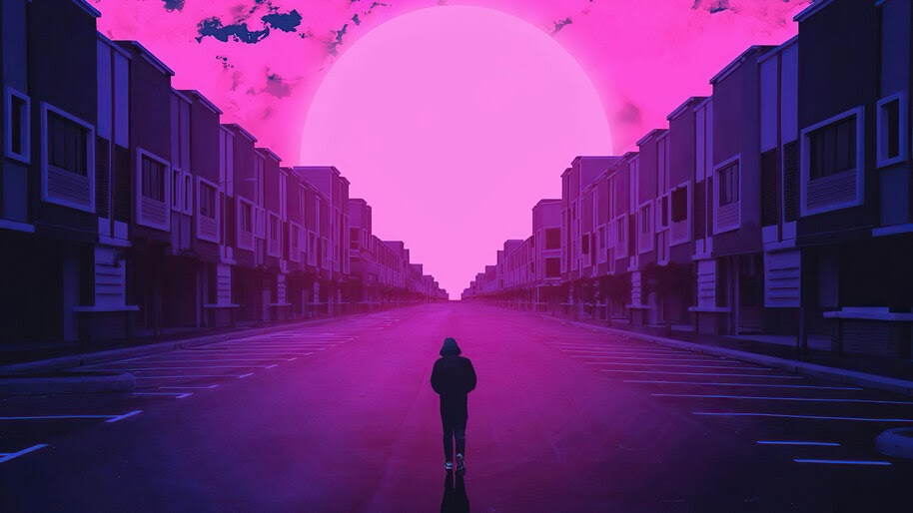

# 6 Summary



Webaverse unlocks value for creators, users, and investors with a principled virtual world based on permissionless innovation and access to liquidity. The things that make a virtual world: avatars, parcels, 3d models, videos, images, and audio are identifiable by their hash and tokenized ASSET, exchanged for the fungible FLUX token. The landscape of Webaverse is always evolving as Seasons create new space for innovation and new LAND tokens. These ingredients together bootstrap the interoperable metaverse.

# References



1. Metaverse. (2020, December 21). Retrieved from <https://en.wikipedia.org/wiki/Metaverse>
2. Exokit. (2017, May 27). Exokitxr/zeo. Retrieved from <https://github.com/exokitxr/zeo/tree/4b7f27b32ed5b09e6b9cdbc854bd3bdbac2622bd>
3. M3. (2019, April 18). First WebXR Meetup in Mozilla Hubs. Retrieved from <https://www.youtube.com/watch?v=auY_jZlOCcY>
4. Fortnite Battle Royale. (2020, December 12). Retrieved from <https://en.wikipedia.org/wiki/Fortnite_Battle_Royale>